“Charity Through Adventure”
The UK 3 Peaks 24 hr Challenge
Saturday 13th & Monday 15th July 2013

Total climb is app 9000ft/ 2900m – walk distance is app 21 miles

Option - Long Day
This option allows both Ben Nevis and Scafell Pike to be climbed in daylight, leaving an easy Snowdon path to be climbed at night.
08.00am | Start Ben Nevis.
01.00pm | Finish Ben Nevis
01.15pm | Drive to Scafell Pike app 6 hours
06.30pm | Arrive and start climbing Scafell Pike
10.30pm | Drive to Snowdon app four hour drive
03.30am | Arrive and start climbing Snowdon
08.00am | Finish Snowdon, and complete challenge.

Travel to Nevis near Fort William on Saturday 13th July
For more details visit:
http://www.thethreepeakschallenge.co.uk/national-three-peaks-challenge/

- GROUP SIZE: 10
MINIMUM FUNDS TO RAISE: £150
Funds raised will go “The Three R`s Charitable Trust “

- COST: app £120 for car share, 1 night bunk bed and some food
Any additional car expenses will be shared

- Administration, registration and training: Satish Shah
- Email: satishshah52a@hotmail.com
- Tel res: 01274 541987

- You will need to have a large car
- You will need the service of a dedicated volunteer car driver
- You will need enough walkers who are able to take on this
serious and punishing challenge. The Yorkshire 3 peaks is a
good training start – 24 miles and 5000ft / 1600m climb

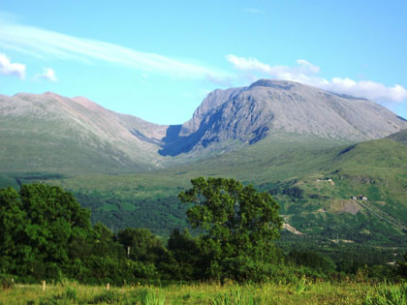

Ben Nevis, the highest of the three peaks at 1344 metres (4409 ft), has only one main path, the path to Ben Nevis starts close to sea level, meaning much greater vertical ascent.

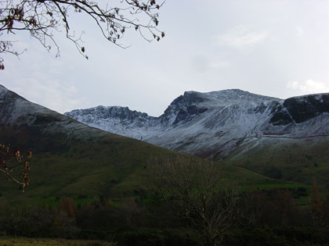

While Scafell Pike has several paths, most Three Peaks Challengers will begin at Wasdale Head, to the North of Wast Water.

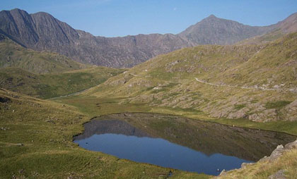

While Snowdon has many paths with varying difficulty, most Three Peaks Challengers will follow either the Pyg Track or Miners Track, leaving from the Pen-y-Pass car park, on the A4086.

